BÀI VỀ NHÀ SESSION 3

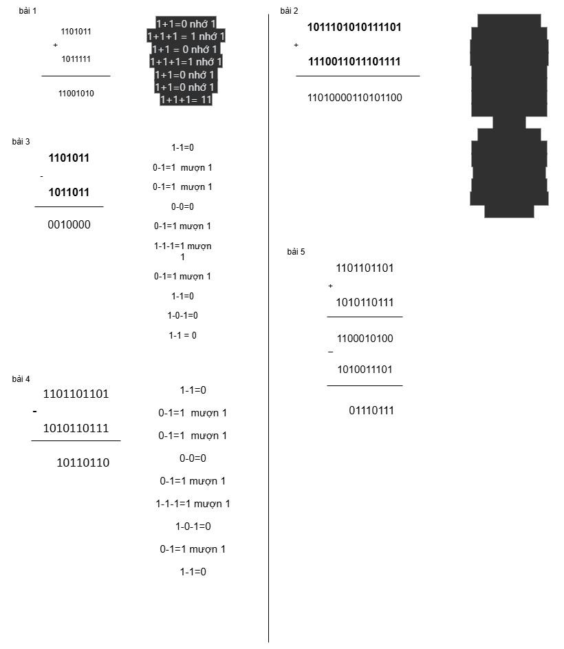

BÀI 6

Ta có: 1101101101(2) - 1010110111(2) + 10011101(2) sẽ có thể biểu diễn theo:

* 1101101101(2) = 2^9 + 2^8 + 2^6 + 2^5 + 2^3 + 2^2 + 2^0 = 877(10)
* 1010110111(2) = 2^9 + 2^7 + 2^5 +2^4 + 2^2 + 2^1 + 2^0 = 695(10)
* 10011101(2) = 2^7 + 2^4 + 2^3 + 2^2 + 2^0 = 157(10)
* 877(10) - 695(10) + 157(10) = 339(10) = 101010011(2)
* BÀI 7

A = 11011001

B = 10110101

A AND B = 10010001

|  |  |  |
| --- | --- | --- |
| 1 | 1 | **1** |
| 1 | 0 | **0** |
| 0 | 1 | **0** |
| 1 | 1 | **0** |
| 1 | 0 | **1** |
| 0 | 1 | **0** |
| 0 | 0 | **0** |
| 1 | 1 | **1** |

BÀI 8

A = 10101011

B = 11010100

A OR B = 11111111

|  |  |  |
| --- | --- | --- |
| 1 | 1 | **1** |
| 0 | 1 | **1** |
| 1 | 0 | **1** |
| 0 | 1 | **1** |
| 1 | 0 | **1** |
| 0 | 1 | **1** |
| 1 | 0 | **1** |
| 1 | 0 | **1** |